PROJECT PROPOSAL

NIHVA TECHNOLOGIES PVT. LTD.
187, G-Block, Thermax chowk, Above Renault Showroom, MIDC
Chinchwad, Pune – 411019.

Customer Name | Trident Group
Project Name | Trident Group
Project Location | Budni ( Dist – Sehore ) Madhya Pradesh & Barnala , Punjab
Contact Person Name | Mr. Shailesh Laddha
Email Id | ShaileshLaddha@tridentindia.com
Contact Number | +91-8349801046

Contact Person: Ms. Varsha
Mob No.: 8551091333
Email id: support@nihva.com
Web: http://www.nihva.com

Dear Sir,
Thank you for your enquiry. Please find below our offer for our NIHVA make Telescopic Belt Conveyor.
100% design and manufactured by NIHVA at PUNE.
We trust that this will meet with your approval and if you have any queries please do not hesitate to contact us.

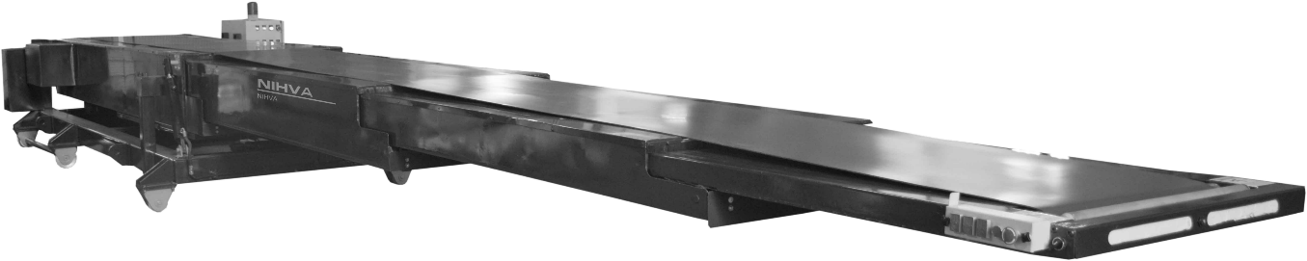

Technical Details of Telescopic Conveyor

Overall Dimensions

Overall closed length | 6000mm standard
Total extended length | 19000mm standard
Cantilevered length | 13000mm standard
General Specification

Height to top of belt | 850mm minimum
Belt width | 600mm nom.
Belt type | Smooth face PVC top, 2 ply
Belt joint | Vulcanized joint
Belt drive | Geared motor unit
Telescopic drive | Synchronized positive chain drive
Loading Capacity

Per metre | 40kg/metre
Control & Operation

Main supply | 415v, 3ph rated at 20amps (per conveyor) 50hz
Main supply connection | Isolated supply to be provided by the customer to control panel
Control voltage | 24v dc
Emergency stops | 1-off front boom
Belt speed | 30m/min. Inverter controlled
Belt direction | Reverse (unloading)
Belt controls | Start / stop push-buttons
Extend/Retract speed | 0.25m/sec
Extend control | Push button on front boom
Retract control | Push button on front boom
Up/Down movement | N/a
Traverse movement | Control station and handle
General Information
Type of front boom | Impact plate
Mounting type | Mobile powered chassis
Color specification | RAL Customer to confirm

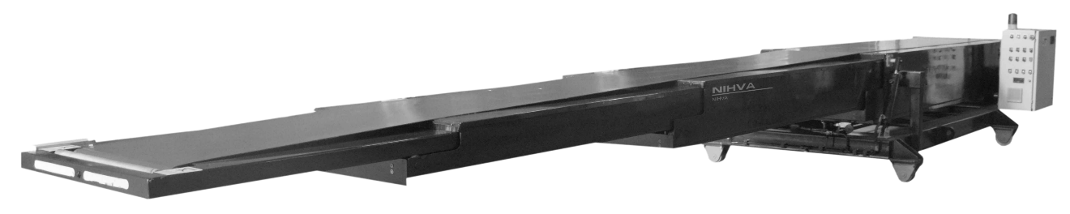

 | Included in Specification
 | Boom end lights |  | LED light units mounted in the front boom providing illumination in the vehicle, the lights automatically switch on when boom extends and switch off when the booms are fully retracted.
 | Audible warning |  | Audible warning to alert operator of impending belt starts.
 | Impact strip |  | Anti-collision strip fitted at the front of the boom which causes the machine to retract should it encounter an  obstacle at the front of the machine.
 | Impact plate |  | 5mm thick impact plate fitted to the front of the machine to take impact from product being dropped onto the machine.
 | Inverter on belt drive |  | Progressive acceleration of belt up to running speed and  controlled stop used when the belt will be subject to regular start / stop operation.
 | Chain sensors |  | Sensors positioned in main casing to detect if boom drive chains slacken due to a fault. When active, sensors stop the  machine preventing further damage.
 | Underside covers |  | Painted sheet steel covers fitted to all telescopic sections to  prevent operators from touching internal moving parts of the machine.
Additional Items

Mobile powered chassis |  | Heavy duty chassis fitted to machine enabling machine to be moved. This is facilitated by two motors and a control handle. The chassis is fully counterbalanced so no extra support is required. Ideal for traversing between doors and storing out of the way.
Rear pop-out roller |  | Interlocked roller fitted to rear. When sensor activated, belt  stops preventing injury. Front pop-out roller is included as standard.

Additional Items to Standard Specification
Mechanical Description | Qty
Low level rear stands top pivot, pair | 1
Hydraulic rams+ power pack low level | 1
Powered mobile counterbalanced chassis (Tiller type) | 1
Electrical Description | Qty
Belt inverter 1.5kw | 1
P.E.C. Parcel Counter / index PEC, includes cover
Reversible Belt | 1
Rear pop out roller, inc sensors | 1
Cable Reeling Drum (15m) | 1

System Operating Parameters
For the purpose of this proposal it is assumed that the system is in use 8 hrs per day, 40 hrs per week, 52 weeks per year.
Environmental conditions are dry, with no adverse fluctuations in temperature or humidity generally between 0 and +35 deg C.

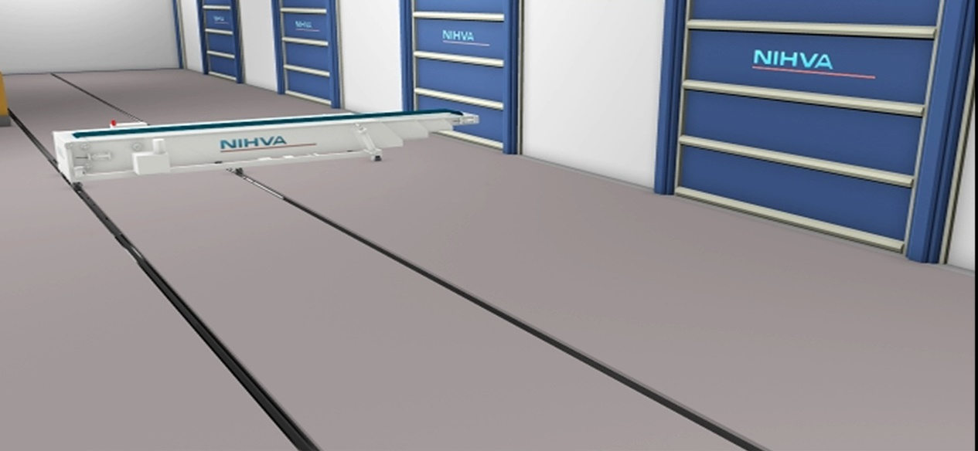

Commercial offer: -

Sr. No. | Description | Qty | Rate In INR | Net Amount INR
1 | Conveyor Type: Telescopic Conveyor  Total Length: 18000 mm  Fixed Length: 6000 mm  Extended Length: 12000 mm  Belt width: 600 mm  Capacity: 40 kg / Meter | 1 | 2,885,000 | 2,885,000
2 | Conveyor Type: Telescopic Conveyor  Total Length: 16500 mm  Fixed Length: 5500 mm  Extended Length: 11000 mm  Belt width: 600 mm  Capacity: 40 kg / Meter | 3 | 2,475,000 | 7,425,000

Terms and Conditions: -

Price : Ex. Works Pune

P & F : 3 % Extra at the time of delivery.

Freight Notes : Extra as applicable.

Delivery : Within 10- 12 weeks from date of receipt of confirmed purchase order, advance payment, drawing approval.

Payment Terms : 80% advance along with confirmed purchase order balance before dispatch.

Insurance : Extra as applicable.

GST : As Applicable on total supply value.

Validity : 15 days from date of quotation.

Warranty : 12 months from date of supply.

Technical Specifications:
Cost efficiencies.
Belt drive system

The belt drive system is energy and therefore cost efficient for the following reasons:
- Drive drum is lagged with a 15mm thick diamond pattern rubber coating
- Belt is driven on the top surface of belt to give maximum drive efficiency as opposed to driving on the underside which has a low coefficient of friction. This means that we do not require as much tension on the belt which in turn reduces the amount of power required from the motor to drive the belt.

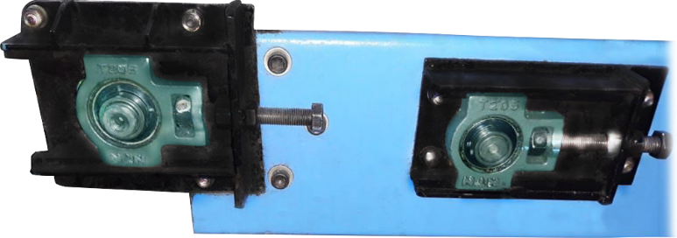

Belt Tensioning system

Reduced cost of ownership

Furthermore, all drive parts are easily accessible through side and rear covers so for service purposes there is easy access.

Because of this easy accessibility the maintenance per year can be reduced significantly. Also, the repairs that are needed can be done easier and quicker.
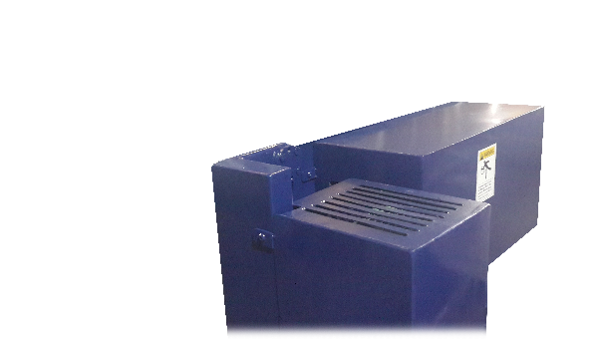

Motors used in the conveyors

SEW Efficient motors are a standard component in the vehicle loaders. NIHVA uses SEW motors as SEW is taking the lead in the race to reduce carbon emissions by supplying IE2 motors as its standard solution now.

LED Lights

LED lights are an energy efficient way of illuminating the workspace inside vehicles. LED lights are positioned in various places to ensure maximum light output is achieved, which do not dazzle the operators. 600mm long strip LED lights are fitted in the front and down the side of the front boom, the light emits a fan shaped light.

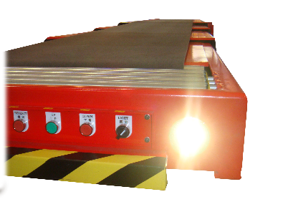

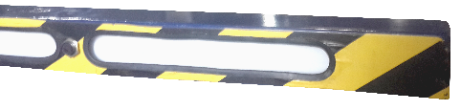

Control panel

Therefore, we have designed a special control panel for each operation both side front side as well back side.

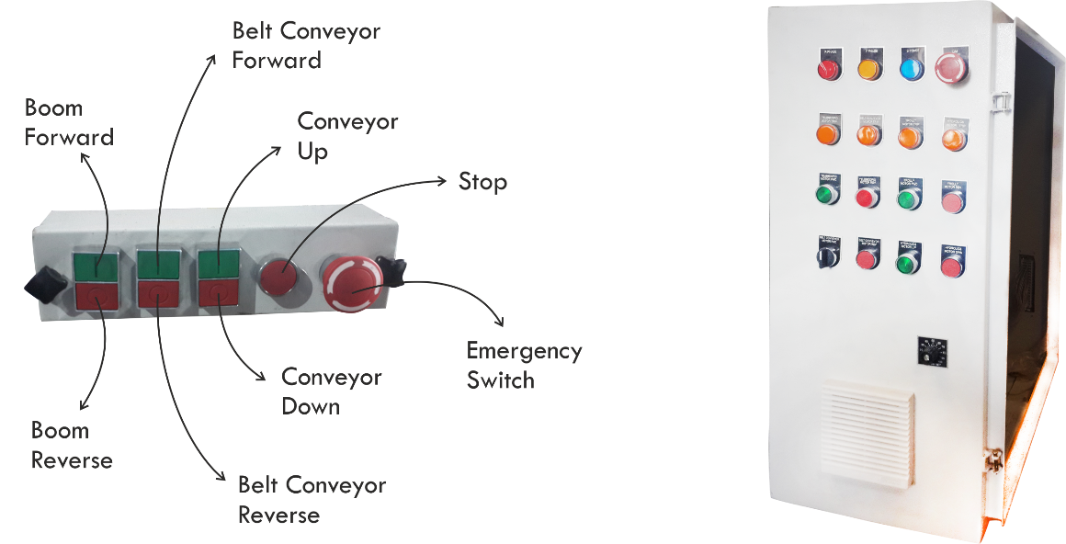

Safety & Ergonomic features

Front boom section

conveyors have front end sections that are very safe and ergonomically designed. They are mounted standard with the following.

- Deep section to cope with the daily arduous task of impact loading.

- Push buttons ergonomically positioned at 45 degrees to allow the operator to clearly see which button is being pressed

- Pop-out roller is electrically switched on outfeed application for added safety for the operator.

- All push buttons are protected by a 5mm thick steel cover plate

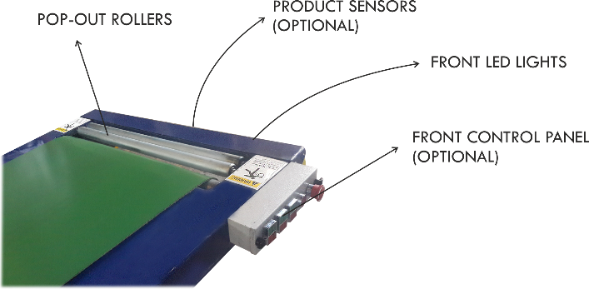

Please feel free to contact Mr. Vijay Tarak - 08551093333 For any further Clarification /Information in this concern

